About this template

This template contains information about the structure of your paper for inclusion in the Papua New Guinea Journal of Agriculture, Forestry and Fisheries and displays the required format. This template should be used in conjunction with the Author Instructions for the Journal to ensure all necessary details are captured.

To use this template, please highlight a field and overwrite the provided information with your text.

Delete this page when you are ready to submit.

There should be a separate Title Page with concise and informative paper title including keywords and full details of authors.
First name Surname^{A,*,#}, First name Middle initial Surname^{B,#} and First name Surname^{A}
^{A}Department, university/workplace, city, state, country.
^{B}Department, university/workplace, city, state, country.
*Corresponding author. Email: xxx@email.com
Important: ORCIDs must be linked to the author accounts in ScholarOne in order to be verified and to appear in the final published paper. Please ensure all co-authors link their accounts (see https://support.silverchair.com/scholarone-manuscripts/faqs/#faqs).
Abstract. Most article types require an abstract. See the Author Instructions of the Journal for any specifics, such as abstract headings and word count. The Abstract should state concisely why the study was done, what hypothesis was tested, how the study was undertaken, the principal findings and conclusions. It should also highlight the implications for future research. Ensure you include keywords and phrases in your abstract. Do not include reference citations, complex equations, lists, tables or figures.
Keywords: insert six to eight keywords to aid online discoverability, lower case except for names, separate with a comma, repeat keywords used in title and abstract.

Heading 1 style: use this style for main headings (Introduction, Methods, Results, Discussion, Conclusion)
Use this style for paragraph text. Australian English spelling is required. Subheadings can be used throughout your text. Styles for subheadings are

Heading 2 style
Heading 2 is used for subheadings within a section with a Heading 1 title.

Heading 3 style
Heading 3 is used for subheadings within a section with a Heading 2 title.

Heading 4 style.
Is used for subheadings within a Heading 3 section.

Quotes
Use this style to display quotations of over 30 words (or as needed). Display quote text. [Source]

Lists
- Use this style for numbered lists
- Use this style for bulleted lists

Abbreviations
Please define abbreviations at first use in the text, for example ‘using generalised estimate equations (GEEs)’. If an abbreviation was defined in the abstract, please define it again at first use in the main text.

Figures, tables and boxes
If present, figures must be cited in text (Fig. 1) in the order in which they appear. For detailed instructions on preparation of figures see the Author Instructions. If figures contain abbreviations not previously defined in the text, ensure definitions are provided in the caption.

Fig. 1. Figures should be numbered in chronological order and have a detailed caption. Captions should provide enough information that the figure can stand alone. Use of colour images and photographs is encouraged. Provide a credit when supplying an image/photograph. If you are using a figure from another publication, please ensure necessary permissions have been obtained to republish.
If present, tables should be prepared either in Word using the ‘Table’ tool (not tabs), avoiding hard returns within cells, or in Excel. Carefully consider the layout of tables and avoid excessive subdivision of columns. If possible do not use coloured shading or text within a table. Use bold or italics for emphasis if needed and ensure usage is explained in the table footnote. If tables contain abbreviations not previously defined in the text, ensure definitions are provided. Tables should also be cited in the text (Table 1) in the order in which they appear.
Table 1. Provide a concise explanation of your table.
Column heading | Column heading | Column heading | Column heading
First data row | 1^{A} | 2 | 3
Second data row | 4 | 5 | 6
SSR | 7 | 8* | 9

Note: this general footnote contains information pertinent to the entire table.
^{A}Footnotes identified with superscript uppercase letters are pertinent to single cells only.
*Asterisks are used to indicate statistical significance (e.g. *P < 0.05; **P < 0.01).
SSR, simple sequence repeat (abbreviations should be defined in the footnote if not already explained in the body of the paper).
Source: Bloggs et al. (2020) [if required].

Equations
Equations can, where appropriate, be included inline with the main body text. Where this is not possible, equations should be provided in an editable format and displayed in the centre of the page with an equation number as shown below. Equations should be cited in the text where needed in the format, Eqn 1.
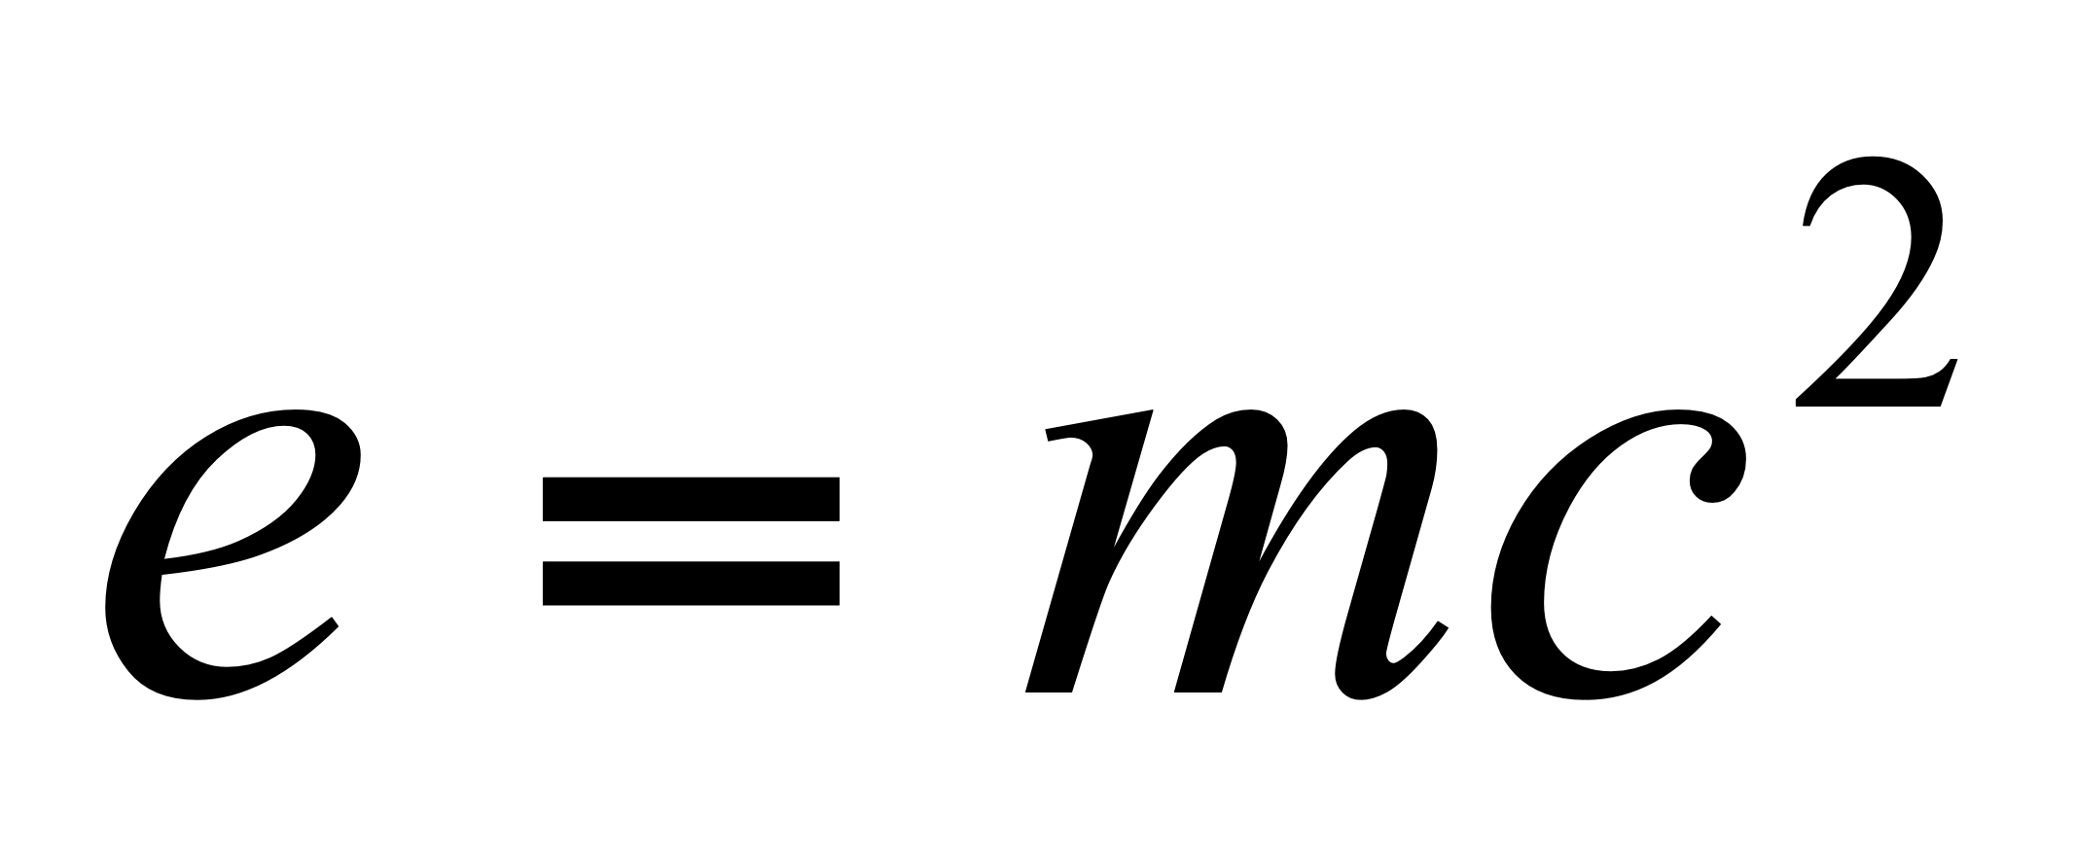 (1)

Units
Use SI units for all measurements unless there are valid reasons for not doing so – these will need full explanation. Units can be provided using either the solidus (mL/day) or using the negative exponent format (mL day^{–1}), but should be consistent throughout your paper. Avoid ambiguous forms of expression such as double solidus (mL/m²/day) but use of format mL/m².day is acceptable.

Data availability (compulsory section)
Include a Data Availability Statement indicating whether the data used to generate the results in the paper are available and, if so, where to access them.

Conflicts of interest (compulsory section)
Include a conflicts statement. If none, please use ‘The authors declare that they have no conflicts of interest.’

Declaration of funding (compulsory section)
Include a funding statement declaring all sources of funding for the research. Include grant numbers if available. If no funding provided, please use ‘This research did not receive any specific funding.’

Author contributions (not compulsory)
You can detail the various contributions of each author here.

Declaration of use of AI (if required)
Ensure any use of AI is declared. See the Journal policies online for guidance.

Ethics statement (compulsory for animal/human research)
For research involving animal or human experiments or data you must provide an ethics statement. This is usually placed in the methods section – or at the end of the manuscript. See the Journal policies online for guidance.

Acknowledgements (not compulsory)
Provide all necessary acknowledgements here.

Supplementary material
If there is supplementary material available with your paper, please provide it as a separate file(s). You should refer to it in the text as ‘Table S1 and Fig. S1, available as Supplementary material’. For further instructions on preparing Supplementary material see the author instructions.

References
References should be included and cited using APA citation style (www.apastyle.org).
In general:
- All listed references should be as complete as possible. In general you must provide: author surnames and initials, year of publication, title of work, title of publication (for a journal/news publication), volume, page range, publisher (for a book or report), URL/DOI if available*
- Do not use ellipses (…) to indicate missing authors
- Articles and books/chapters that have been accepted for publication (in press) should be included in the reference list
- Publicly available datasets should be included in the reference list. Dataset citations should include at a minimum: all authors, year of publication, title of dataset, record ID, publisher, DOI or URL if available
- Unpublished reports, personal communications and submitted/under review manuscripts should not be included in the reference list. Cite these in parentheses in the body of the text, e.g. (A. Smith and B. Jones, unpubl. data; J. Bloggs, pers. comm.). Note: authors must ensure that they have permission to cite material as a personal communication and can provide unpublished data if required by a reviewer
- Generic/home web pages that are continuously updated should not be included in the reference list. Include these in parentheses in the body of the text (e.g. www.publish.csiro.au)
- Government Acts generally do not need to be included in the reference list, however they must be written out in full at first appearance in the text (e.g. Freedom of Information Act 1982 (Cth) (FOI Act))
- For references in languages other than English please provide details of the published language in square brackets at the end of the reference (e.g. Wang JX, Kong FZ, Chen ZF, Zhang QC, Cheng YR, Zhou MJ (2019) Characterization of pigment composition of six strains of Phaeocystis globosa. Oceanologia et Limnologia Sinica 3, 611-620 [In Chinese with English title and abstract]).
*Include DOIs in your list where possible. During production missing DOIs will be added to references where these are available.

Footnotes are not preferred, but if required this is footnote style.

